Calendar on C

## Team members:

1. RA2111001010046 - Ragala Meera Madhu
2. RA2111039010042 - Dhanalakshmi R
3. RA2111001010047 - Gowtham S

## Brief Introduction about the project:

This mini project allows you to view the cricket score of cricket players

## Program:

#include<stdio.h>

struct cricketer

{

int runs,wickets;

char name[25];

}player[100],t;

void main()

{

int i,j,n;

printf("Enter the no of cricket players\n");

scanf("%d",&n);

printf("Enter player info as name , wickets taken , runs scored\n");

for(i=0;i<n;i++)

{

scanf("%s %d %d",player[i].name,&player[i].wickets,&player[i].runs);

}

for(i=0;i<n;i++)

{

for(j=0;j<n-1;j++)

{

if(player[j].runs>player[j+1].runs)

{

t=player[j];

player[j]=player[j+1];

player[j+1]=t;

}

}

}

printf("\nCricketer info in terms of runs scored from lowest to highest\n");

printf("\nNAME\t\tWICKETS\t\t\tRUNS_SCORED\n");

printf("-------------------------------------------------------------------------------\n");

for(i=0;i<n;i++)

{

printf("%s\t\t\t%d\t\t\t%d\n",player[i].name,player[i].wickets,player[i].runs);

}

}

## Sample Input and Output :

Sample input.

Sample output.

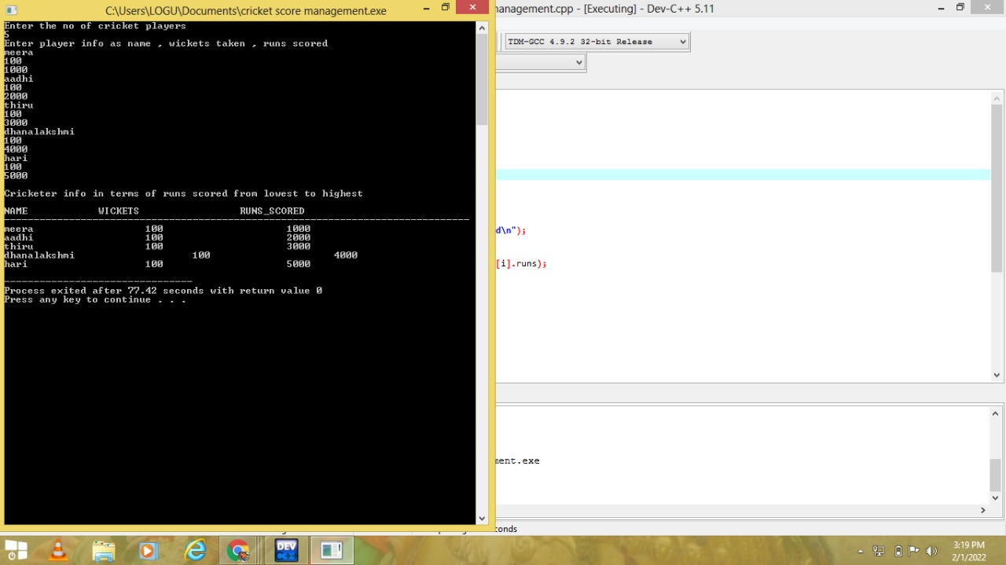

## GitHub link:

https://github.com/RA2111001010046/cricket-score-management.git